Do motorcycle helmet laws relate to fatalities?
Data Literacy Project

Background: This week’s Graph of the Week is a little different in format. The New York Times has put together a series of graphs related to changes in different states’ motorcycle helmet laws, and crashes and fatalities of motorcycle riders and vehicles in general. Scroll through the series of graphs, and use the discussion prompts below. Here is the link:
http://www.nytimes.com/interactive/2014/03/31/science/motorcycle-helmet-laws.html?_r=1

If you don’t have access to the online version of the graphs, here is just one example, related to changes in vehicle fatalities overall, through time.

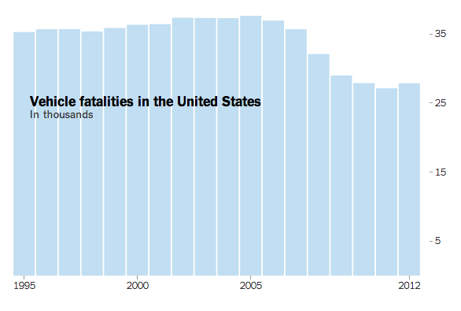
NY Times caption: Fewer people are dying in vehicle accidents compared with recent decades. Federal safety officials credit less driving during the economic slowdown and the enforcement of better safety standards.

Data Source: http://www.nytimes.com/interactive/2014/03/31/science/motorcycle-helmet-laws.html?_r=1

- As you scroll through the graphs, stop and ask various students to “describe this graph, what this graph shows, what this graph tells me”. Note: some graphs are displayed in total numbers of crashes, etc., whereas others use percent on the Y-axis. Be certain that students are reading the graphs correctly with respect to the Y-axis units.
- Ask students to identify each graph by type (for example: time series, bar graph, histogram…). Using the Graph Choice Chart, do you think that the graph is answering the question that the researcher wondered about? What graph might have been better to use?
- Ask students what’s one question you wonder, now that you have looked through these graphs? Write down the question, and using the Graph Choice Chart, identify what type of graph you would use to address that question.

