Are fish moving north?
Data Literacy Project

Background: One more graph from the newly-released climate report! Scientists wonder if climate change will affect the ranges (where animals live) of Atlantic Ocean groundfish (fish that live on the sea bottom). If temperatures rise, and then ocean temperatures rise, will it be too warm in some places for cold-loving fish to live? If so, will they move northward, seeking cooler waters?

The graph below shows where four species of groundfish (commercially, lobster is considered a groundfish) have been caught over the past 40 years. On the Y-axis, the authors are displaying the average latitude of the bulk of the commercial catch for these species. Lines of latitude are the imaginary lines around the Earth that tell you how far north or south you are. In the Northern Hemisphere, as latitude goes up, you are getting closer to the North Pole.

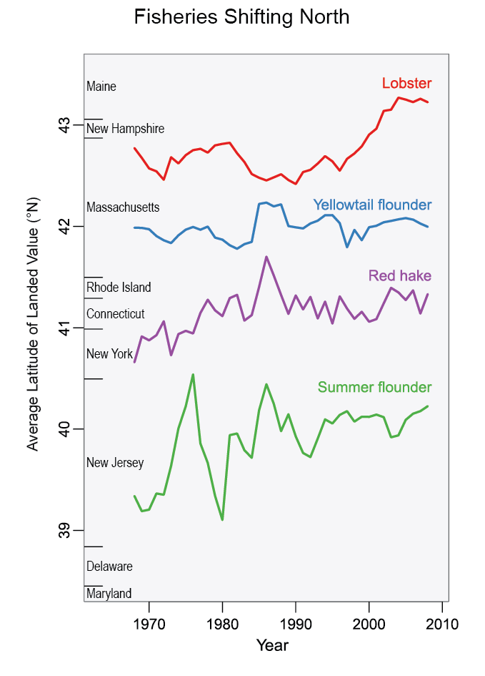
Data Source: http://nca2014.globalchange.gov/highlights/report-findings/oceans; Figure source: adapted from Pinsky and Fogerty 2012.

1. Describe what the graph shows about how the distribution of groundfish landings are changing. (Purpose here is to elicit description of what the graph shows. Sample response: Most of the lines go up (are more northerly) as time has passed. Yellowtail flounder landings have bounced around but not really increased in latitude with time.)

2. The caption given in the report is,
“Ocean species are shifting northward along U.S. coastlines as ocean temperatures rise. As a result, over the past 40 years, more northern ports have gradually increased their landings of four marine species compared to the earlier pattern of landed value. While some species move northward out of an area, other species move in from the south. This kind of information can inform decisions about how to adapt to climate change. Such adaptations take time and have costs, as local knowledge and equipment are geared to the species that have long been present in an area.”
Based on the evidence in the graph, do you think the scientists’ claim about the data makes sense? What features of the data in the graph support their claim?

