Are birds moving northward as the climate changes?
Data Literacy Project

Background: Every year at Christmastime since 1900, volunteer citizen scientists go outside to count birds as part of the Audubon Society’s Christmas Bird Count (read more about it here: http://birds.audubon.org/christmas-bird-count). Volunteers spend time in areas around North and South America counting how many birds of different species they see. This huge effort has resulted in one of the longest-running datasets in the world – which allows scientists to look at patterns and trends in bird populations (numbers of different bird species) and ranges (where they live). One way scientists are using the data is to see if birds are moving as climate warms up. If a bird likes a fairly cold climate, will it move north if it’s now too hot in its old home range?
This graph below shows how bird “center of abundance” – where most birds live – has changed through time, from 1966-2005. The middle orange line is showing the average distance moved for 305 bird species every year. The shaded band shows the likely range of values, based on the number of measurements collected and precision of the methods used.
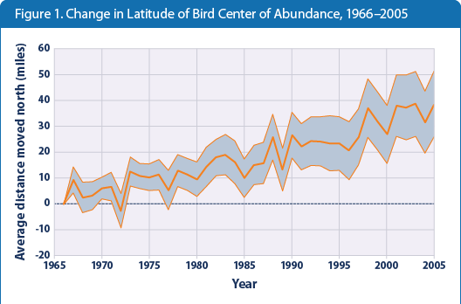
Data Source: US EPA, citing National Audubon Society, 2009 http://www.epa.gov/climatechange/science/indicators/society-eco/bird-ranges.html

1. Describe what the graph shows about how bird ranges are shifting northward through time.
(Purpose here is to elicit description of what the graph shows. Sample response: Among 305 widespread North American bird species, the average mid-December to early January center of abundance moved northward between 1966 and 2005. The average species shifted northward by 35 miles by the end of this period).

2. I interpret the graph to mean…. (Purpose here is to elicit an explanation (e.g. of the pattern or variability) or interpretation of the meaning in terms of the context of the question. Sample response: If we believe that climate has warmed, then this is evidence that the warming might be causing some species to adapt and move.)
Teacher’s notes some additional probes:
- Ask students: what would you graph if you wanted to see if climate change was related to the northward shift in bird ranges? (You would probably want to plot something like air temperature versus shift in bird range. See if students can sketch out what that graph would look like).
- The EPA page with this graph (http://www.epa.gov/climatechange/science/indicators/society-eco/bird-ranges.html) has lots of great interpretation and more information.

