Are birds moving northward as the climate changes?
Data Literacy Project

Background: Every year at Christmastime since 1900, volunteer citizen scientists go outside to count birds as part of the Audubon Society’s Christmas Bird Count (read more about it here: http://birds.audubon.org/christmas-bird-count). Volunteers spend time in areas around North and South America counting how many birds of different species they see. This huge effort has resulted in one of the longest-running datasets in the world – which allows scientists to look at patterns and trends in bird populations (numbers of different bird species) and ranges (where they live). One way scientists are using the data is to see if birds are moving as climate warms up. If a bird likes a fairly cold climate, will it move north if it’s now too hot in its old home range?
This graph below shows how bird “center of abundance” – where most birds live – has changed through time, from 1966-2005. The middle orange line is showing the average distance moved for 305 bird species every year. The shaded band shows the likely range of values, based on the number of measurements collected and precision of the methods used.
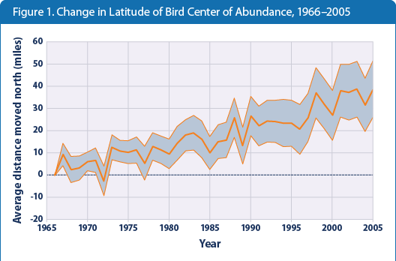
Data Source: US EPA, citing National Audubon Society, 2009 http://www.epa.gov/climatechange/science/indicators/society-eco/bird-ranges.html

1. Describe what the graph shows about how bird ranges are shifting northward through time.

2. I interpret the graph to mean….

