Do people who make more money tend to spend more on holiday gifts?
Data Literacy Project

Background: Economists (people who study how money is earned and spent) use the “per capita GDP”, where GDP stands for Gross Domestic Product, to show how much, on average, each person in a country makes in salary and wages. Think about what you might do if you suddenly were rich – would you buy lots of expensive gifts for your friends and family? If so, you might make a claim that people who make more money tend to spend more money.
This graph below shows how much money people in different countries make, and how much they spend on holiday gifts. Do the richest countries spend the most? Which countries don’t fit?
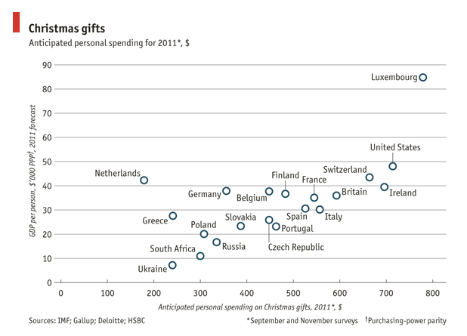
Data Source: The Economist, http://www.economist.com/blogs/graphicdetail/2011/12/daily-chart-1
Note: if the link to the Economist is broken, click here for another version: http://www.theatlantic.com/business/archive/2011/12/christmas-gift-giving-by-country-or-why-are-the-dutch-so-stingy/249948/

1. Describe what the graph shows about how GDP is related to spending on gifts.
(Purpose here is to elicit description of what the graph shows. Sample response: Each dot is a country. The GDP is the amount each person earns (on average, for the whole country), and the anticipated personal spending is how much they spend on gifts. As GDP increases, so does spending.)

2. I interpret the graph to mean…. (Purpose here is to elicit an explanation (e.g. of the pattern or variability) or interpretation of the meaning in terms of the context of the question. Sample response: The graph shows that as people make more money, they tend to spend more on holiday gifts. That is to say, there appears to be a positive correlation between GDP and gift spending.)
Teacher’s notes some additional probes:
- What happened in the Netherlands? Check out some of the narrative about this graph on the original source web site (s). Where does the US fall?
- What is the dependent and what is the independent variable? Is there a better way to arrange the axes of this graph? Can you imagine a question where gift spending was independent? It seems less likely, yet this graph-maker has chosen to show it that way. Would you suggest they switch the axes?

