Do people who make more money tend to spend more on holiday gifts?
Data Literacy Project

Background: Economists (people who study how money is earned and spent) use the “per capita GDP”, where GDP stands for Gross Domestic Product, to show how much, on average, each person in a country makes in salary and wages. Think about what you might do if you suddenly were rich – would you buy lots of expensive gifts for your friends and family? If so, you might make a claim that people who make more money tend to spend more money.
This graph below shows how much money people in different countries make, and how much they spend on holiday gifts. Do the richest countries spend the most? Which countries don’t fit?
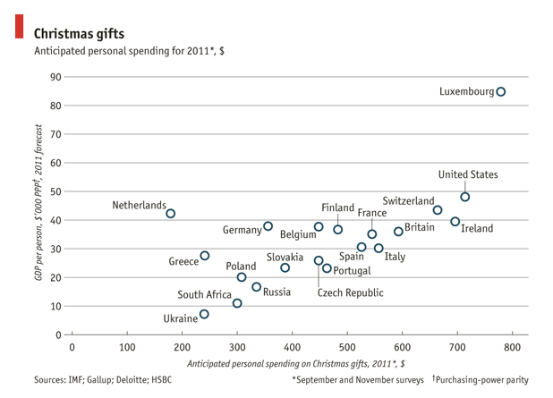
Data Source: The Economist, http://www.economist.com/blogs/graphicdetail/2011/12/daily-chart-1
Note: if the link to the Economist is broken, click here for another version: http://www.theatlantic.com/business/archive/2011/12/christmas-gift-giving-by-country-or-why-are-the-dutch-so-stingy/249948/

1. Describe what the graph shows about how GDP is related to spending on gifts.

2. I interpret the graph to mean….

