Whose hand would YOU shake?
Data Literacy Project
Background: Public health officials often remind all of us that one of the best ways to prevent the spread of germs and keep from getting sick is washing our hands often, and especially after using the bathroom. In order to see if people were washing their hands when signs reminding them to do so were posted, the Minnesota Department of Health decided to do a study, at the State Fair. They went to three big events: a car show in 2003, the State Fair in 2003, and the State Fair in 2004, and observed how many people were washing their hands in the bathrooms.
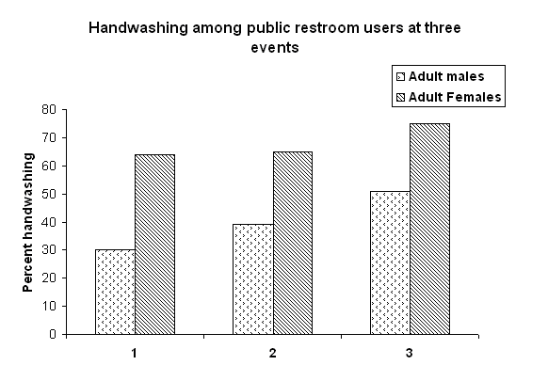
The graph below shows “Average observed hand washing percentages among adult males and females at the Back-to-the fifties car show (1), the 2003 Minnesota state fair (2), and the 2004 Minnesota state fair (3). All observations were carried out in the same two male and two female restrooms.”
Data Source: Minnesota Department of Health, http://www.health.state.mn.us/handhygiene/stats/fairstudy.html

1. Describe what the graph shows about how the percentage of people washing their hands varied in the three events, and in the two genders (male and female).
(Purpose here is to elicit description of what the graph shows. Sample response: In all of the three events, it looks like adult women were more likely than men to wash their hands. At the car show (event 1), women were more than twice as likely to wash, whereas at the 3rd event, women were about 50% more likely to wash than men).]

2. The authors of the study thought that this graph shows, “Observed hand washing rates among both male and female adults showed an increasing trend during the study; however, the increase was more significant among males.” Do you agree with this interpretation? Is it just that men are generally more variable in handwashing than women are, or is there a truly a trend through time for men? How could this be tested? (Purpose here is to elicit a discussion of the graph and the approach, as well as “what does it mean?”)
Note for teachers: There is a really nice, short report of this study as a printable pdf on the web site: http://www.health.state.mn.us/handhygiene/stats/fairstudy.html

Right at the top, click the link to “Download PDF version formatted for print”. There are other graphs in the report, including one that has data on youth washing rates, and it’s really only a couple of pages long. This is a nice opportunity to have students think about peer-reviewing – do they ‘buy’ the authors’ interpretations of the data? What would they do differently if they were doing the study?

