How does temperature relate to concentration of greenhouse gases?
Future of Four Seasons in Maine and the Maine Data Literacy Project

Background: We hear a lot about global warming in the news, and typically carbon dioxide (CO₂) is blamed for the changing temperatures. But there are other gasses that are also affecting our climate and contributing to the greenhouse effect.
The graphs below are scatter plots showing the correlation between temperature anomaly and concentration of two different greenhouse gasses, CO₂ and CH₄ (methane), in parts per million and parts per billion, respectively. The data come from the Vostok ice core that contained 420,000 years of Earth’s climate history.
A temperature anomaly is measured by taking the average temperature over a long period of time and comparing that average to the average temperature over a shorter period of time. For example, if the average temperature for Bar Harbor from 1900 to 1999 was 11°C and the average temperature for 1952 was 13°C, then the temperature anomaly for 1952 would be +2°C, meaning that 1952 was 2°C warmer, on average, than the long-term temperature.
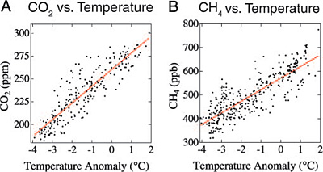
Data Source: http://www.earthinstitute.columbia.edu/news/2004/story11-11-04b.html

- Describe what the graph shows about the relationship between temperature anomaly and CO₂ and CH₄ concentrations.

2. I interpret the graph to mean….

Bonus Question: If the relationships displayed in the graphs were causal, which gas is likely the more powerful greenhouse gas?

