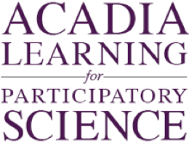
How do the hare and lynx populations relate?
Future of Four Seasons in Maine and the Maine Data Literacy Project

Background: Scientists use models to predict how a system will behave into the future. They will often use real data to validate their models and to see if they actually represent reality.
The graph below shows two relationships through time. One is the relationship of modeled lynx (red line) and hare (blue line) populations to data collected in the field (red dots for lynx data, blue dots for hare data). The other is the relationship between the lynx and hare populations themselves. Because lynx are predators that feed almost exclusively on hare, their population is tied closely to the population of the hares.
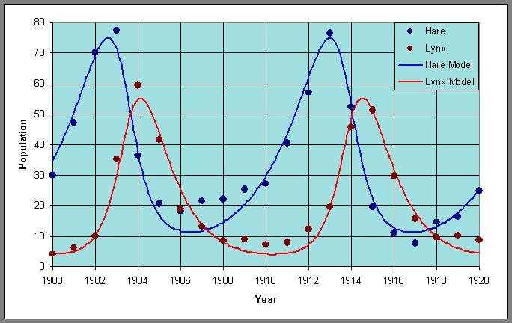
(X1000)
Data Source:
http://www-rohan.sdsu.edu/~jmahaffy/courses/f09/math636/lectures/lotka/qualde2.html

1. Describe what the graph shows about how well the model fits the trends in the data.
Purpose here is to elicit description of what the graph shows. Sample response: Over all the model fits the data very well with highs and lows in the actual populations of both animals lining up well with the models.

2. Describe what the graph shows about how the hare and lynx populations relate to each other.
Sample response: The hare population peaks about a year before the lynx population, and it bottoms out about four years before. Both animals follow a boom bust cycle that has a period of about 10 years.

3. I interpret the graph to mean…. (How do the lynx and hare populations relate?)
Purpose here is to elicit an explanation (e.g. of the pattern or variability) or interpretation of the meaning in terms of the context of the question. Sample response: Because the lynx depend on hares for food, when the hare population is high it is able to support a high lynx population. When the lynx population reaches a point where they are killing hares faster than they are reproducing, the hare population will decline, followed by the lynx population.

