How are the oyster beds doing?
Future of Four Seasons in Maine and the Maine Data Literacy Project

Background: Smart management of our natural resources is important if we hope to have access to them into the future. This study looked at how oyster beds have changed size in three different regions of the United States from a historical baseline, measured between 1878 and 1935, and modern conditions, measured between 1968 and 2010.
The graph below shows the percent of bays covered by oysters historically, and in modern times. Each pair of box plots shows how the modern oyster bed areas have changed relative to the historical values.

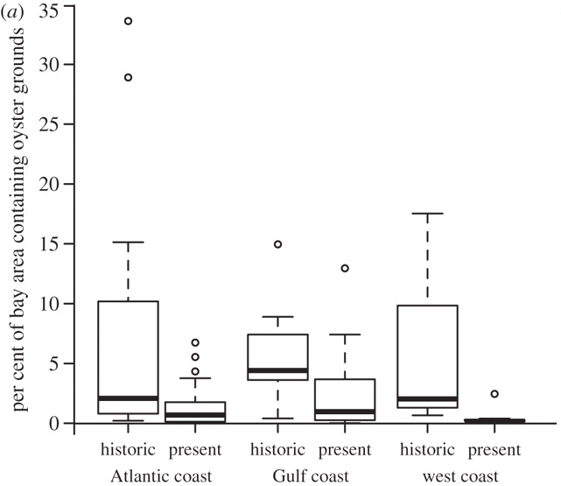
Data Source:
http://rspb.royalsocietypublishing.org/content/early/2012/06/07/rspb.2012.0313.figures-only

1. Describe what the graph shows about how the area of the historical oyster beds have changed relative to the modern measurements.
(Purpose here is to elicit description of what the graph shows. Sample response: In all three regions the size of the oyster beds appear to have shrunk in modern times. The variability among the data points has also reduced.)

2. I interpret this graph to mean…
(Purpose here is to elicit an explanation (e.g. of the pattern or variability) or interpretation of the meaning in terms of the context of the question. Sample response: Oysters have not been able to reproduce as quickly as they being killed. The populations all around the country may be shrinking from overfishing or habitat degradation, but the graph does not explain why.)

