How are dissolved oxygen related to levels water temperature?
Future of Four Seasons in Maine and the Maine Data Literacy Project

Background: Fish, just like mammals, need oxygen to survive. However, fish use oxygen dissolved (DO) in the water rather than the air. The National Oceanic and Atmospheric Administration (NOAA) monitors dissolved oxygen in sites all over the country including several stations in Wells, ME. There are many different factors that can affect dissolved oxygen levels which can in turn affect fish populations.
The graph below is a scatter plot of dissolved oxygen data from 2014 where the Y axis shows dissolved oxygen in mg/L and the X axis shows water temperature in degrees Celsius. If a sample contains 5 mg/L dissolved oxygen, that means a one liter sample of water would contain 5 mg or oxygen.

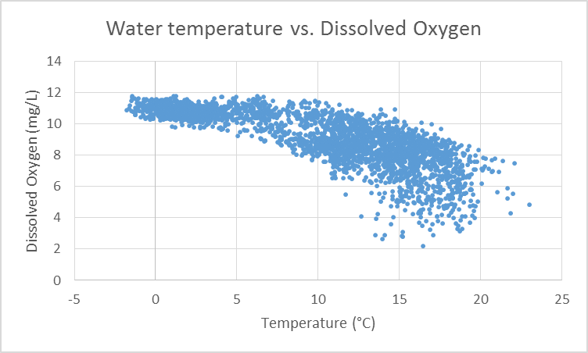

Data Source: http://estuaries.noaa.gov/ScienceData/Graphing.aspx

1. How do dissolved oxygen and water temperature relate to each other? Describe the evidence contained in the graph to support your claim.
(Purpose here is to elicit description of what the graph shows. Sample response: There is a correlation between water temperature and dissolved oxygen. All of the data points are clustered along a single line showing that as the water temperature increases the dissolved oxygen decreases.)

2. I interpret the graph to mean…(How do you think a change in water temperature will affect fish that need a lot of oxygen?)
(Purpose here is to elicit an explanation (e.g. of the pattern or variability) or interpretation of the meaning in terms of the context of the question. Sample response: Because warm water contains less dissolved oxygen than cold water, fish that need a lot of oxygen would likely prefer cold water.)

Teachers: A more advanced analysis of this graph shows a limit of dissolved oxygen and temperature as the water approaches the freezing point and an increase in variability of dissolved oxygen as the water warms. The following questions could be used to get students thinking about this.

Describe how variability in DO changes as temperature warms. What might be the reason for any observed change in variability?

