Snowpack project, Lesson 2: A primer on snow

Assignment 3: Calculating snow density

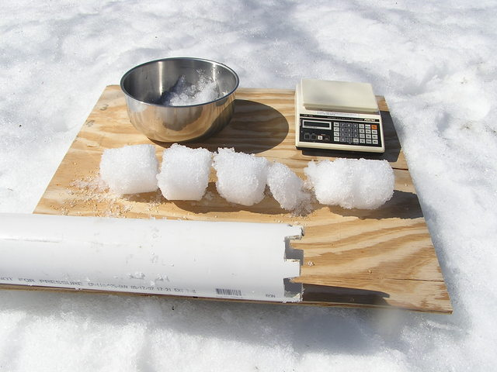
Later in this snowpack project you may collect data on the snowpack (the accumulation of snow on the ground). Not all snow is the same and an important piece of data to collect about snow is its density. Before you head into the field it is important that you practice calculating snow density.
Figure 1 from http://wermenh.com/wx/winter_0808.html

You will be using cylinder of a known inner diameter to collect your snowpack samples (probably a piece of PVC). You will push (and twist, if needed) the cylinder into the snow and then, after recording the depth to which you plunged the cylinder, you will pull the cylinder out with a plug of snow in the bottom.

Snow density is measured by collecting that vertical core of snow with the cylinder. The volume is calculated by knowing how much of the cylinder is filled by snow (there are depth markers on the outside of the cylinder). After pulling the cylinder out of the snow the plug of snow is emptied into a Ziploc bag and weighed (you can do this back in the classroom). This weight is the mass (in grams) of the snow in the cylinder (you will subtract the weight of the Ziploc bag later).

Density is a measure of mass (weight in grams) per unit of volume. The symbol for density is r (the Greek symbol rho). The equation for snow density is therefore: r = Mass (g)/Volume (cm³).
We know the volume of a cylinder is calculated: V=πr²h

So, if we have 4 cm of snow in a cylinder we know to be 10.16 cm (4 inches) in diameter (5.08 cm radius) then we know we have 324 cm³ (V= π (5.08)²(4))

If the mass of the snow was 5.3 grams, for example:
A cylinder contains 324 cm³ of snow with a weight of 5.3 grams (you weighed it back in the classroom):
r = 5.3 g/324 cm³ = 0.016 g/cm³

Calculate the density for the following snow samples:
Sample # | Height of snow sample (cm) | Mass (g) | Density
1 | 24 | 212
2 | 18 | 91.9
3 | 72 | 1004
4 | 4 | 89.2
5 | 41 | 173

