**How do indoor and outdoor temperatures change from night to day?**

Data Literacy Project

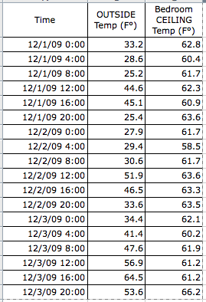**Background**: Liz wanted to know how much the temperature inside her house changes between night and day. She monitored the temperature in an upstairs bedroom and outdoors in her yard in the shade, using automatic data loggers. The loggers measured the temperature every four hours for three days in December, 2009.

**Question**: *How did the temperature in the two locations change over the three days?*

1. Which of the following best describes the question above?
2. It asks how a measure varies within a group
3. It asks how two or more groups compare, based on a single variable, or measure
4. It asks about correlation between two numeric variables
5. It asks how something changes through time
6. None of the above phrases describe the question very well?

2. What kind of graph would be best to use to answer this question?

(Use the Graph Choice Chart to make your decision.)

3. Graph the data below.

4. Write a claim about the graph in answer to the question “*How did the temperature in the two locations change between night and day during the three days?*”