## Earthquakes

Data Literacy Project

**Background**: The US Geological Survey (USGS) makes data about earthquakes available from seismographs all over the world. In addition to providing the data presented below, the USGS web site has a real-time map of earthquakes as they occur around the world, and an archive of historic major quakes. (Source: US Geological Survey, http://earthquake.usgs.gov)

**Question**: How has the intensity of earthquakes in California and Alaska changed over the last 130 years?

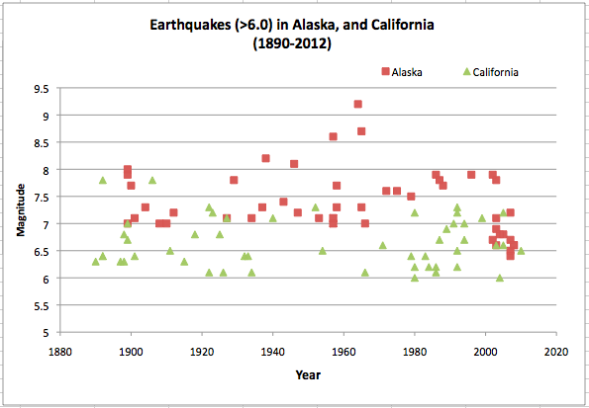

1. Which of the following best describes the question above?
   1. It asks about how a measurement varies within one or more groups
   2. It asks about how two groups compare in a single measurement
   3. It asks about the correlation between two variables
   4. It asks about how something changes through time
   5. None of the above describes my question very well
2. What kind of graph is shown?
3. What story does the graph tell about the question?