## Marine water and air temperatures

Data Literacy Project

Several Federal, State, and private research institutions collaborate to maintain a system of marine buoys located in many US and Canadian coastal waters. The buoys monitor many variables, including air pressure, wind speed and direction, wave height, speed and direction of currents, visibility, air temperature, surface water temperature, at the water temperature at several depths. Maps of the Gulf of Maine buoy locations and data from the buoys are available online from the Northeastern Regional Association of Coastal and Ocean Observing Systems (NERACOOS).

The data for hourly air and surface water temperatures at the West Penobscot Bay buoy between Oct 9 and Oct 16 are displayed in a scatter plot below.

**Question:** Describe the correlation between air temperature and water temperature at the West Penobscot Bay Buoy during this fall week?

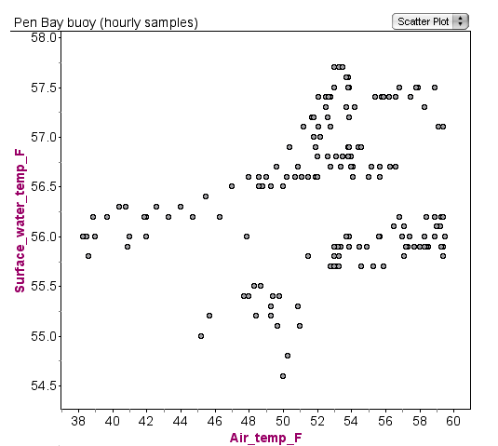

[Data are from the Gulf of Maine Buoy system http://www.neracoos.org/datatools/historical/graphing_download]