**Where is the insulation in Liz’s house?**

Data Literacy Project

Data Literacy Project

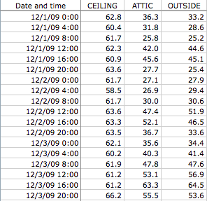

**Background**: Liz used automatic temperature loggers to track the temperature in the upstairs bedroom, in the attic, and outside her house in the shade. The temperatures recorded every 4 hours in each location are given in the table to the left.

**Questions**:

*How strongly is the attic temperature correlated with the outside temperature?*

*How strongly is the attic temperature correlated with the bedroom temperature?*

1. Which of the following best describes these two questions*?*
2. They ask how a measure varies within a group
3. They ask how two or more groups compare, based on a single variable, or measure
4. They ask about the correlation between two numeric variables
5. They ask how something changes through time
6. None of the above phrases describe the questions very well

2. What kind of graph would be best to use to answer these questions? Use the Graph Choice Chart to make your decision.

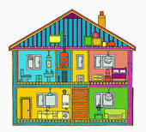3. a. On a separate piece of paper, or using a computer, plot the data in two different graphs.

b. Based on the graphs, where do you think the insulation is in Liz’s house: in the roof, or in the ceiling above the bedroom?