## Driving to distraction

Data Literacy Project

The National Highway Traffic Safety Administration reports that in 2009, 80% of accidents and 16% of highway deaths were the result of distracted drivers. Curious about sources of distraction that could lead to a delayed reaction and thus possible car accidents, students in the Biology Lab at the Hutchinson Center tested one another using various sources of distraction to determine their effect on reaction time.

**Question:** Does reaction time increase when you are distracted rather than focused?

***Study design****: Data were collected using BIOPAC physiology testing equipment. With earphones, a subject hears 20 beeps at random intervals and pushes a button on a hand held device as soon as they hear each beep. BIOPAC records the length of time between the signal and the subject’s response. The subject responds to a series of 20 randomly timed beeps once while focused, and then again while distracted. "Distracted" here represents the subject’s reaction times while reading out loud.*

|  |  |  |
| --- | --- | --- |
| **Beep #** | **Focused (seconds)** | **Distracted (seconds)** |
| 1 | 0.396 | 0.336 |
| 2 | 0.268 | 0.438 |
| 3 | 0.286 | 0.282 |
| 4 | 0.286 | 0.412 |
| 5 | 0.284 | 0.188 |
| 6 | 0.250 | 0.334 |
| 7 | 0.324 | 0.262 |
| 8 | 0.246 | 0.304 |
| 9 | 0.238 | 0.432 |
| 10 | 0.226 | 0.262 |
| 11 | 0.352 | 0.368 |
| 12 | 0.274 | 0.308 |
| 13 | 0.214 | 0.254 |
| 14 | 0.230 | 0.206 |
| 15 | 0.328 | 0.330 |
| 16 | 0.202 | 0.196 |
| 17 | 0.180 | 0.236 |
| 18 | 0.170 | 0.272 |
| 19 | 0.162 | 0.214 |
| 20 | 0.238 | 0.292 |
| MEAN | 0.258 | 0.296 |

1. Based on the results in the table, do the data suggest that the reaction time increased (i.e. was slower) when the student was distracted rather than focused? Explain your answer.
2. The graph below displays a dot plot of the “Focused” and “Distracted” data from the table on the previous page. Draw a box plot around the data.

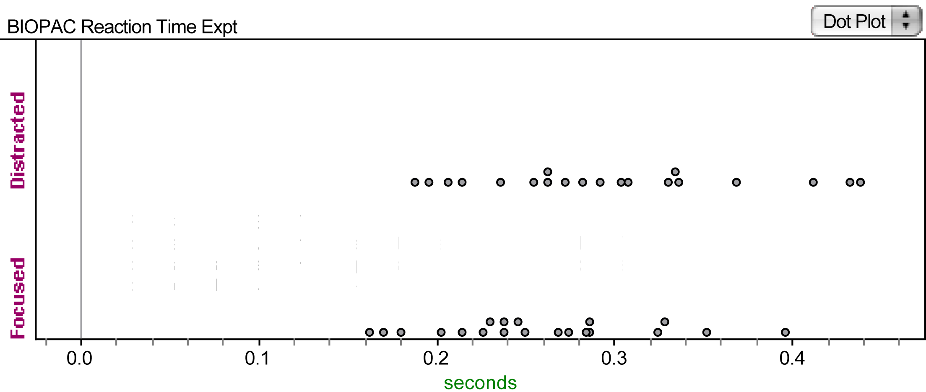

1. Describe the variability for each test.
2. What statement can you make about the difference between reaction times of the individual when she was focused and when she was distracted?