**How stable are temperatures inside Liz’s house compared with temperatures outside?**

Data Literacy Project

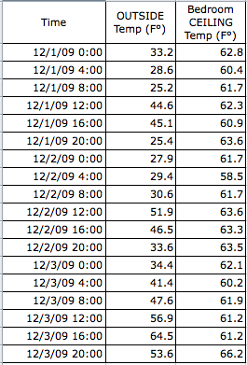

**Background**: Liz lives in an old house in Bucksport, Maine. She wondered if the insulation in her house was good enough to keep the inside temperature of the house stable, even when it was cold outside. She set out two automatic temperature loggers, one near the ceiling in the second-story bedroom, and one outdoors in her yard in the shade. The loggers recorded the temperature every four hours for 4 days in December 2009.

**Question**: *Is the temperature inside the house more stable (less variable) than the outside temperature?*

1. Which of the following best describes the question, *Is the temperature inside the house more stable than the outside temperature?*
2. It asks how a measure varies within a group
3. It asks how two or more groups compare, based on a single variable, or measure
4. It asks about the correlation between two numeric variables
5. It asks how something changes through time
6. None of the above phrases describe the question very well

2. What kind of graph would be best to use to answer this question? (Use the Graph Choice Chart to make your decision.)

3. Graph the data. Write a claim about the graph in answer to the question “*How stable is the temperature inside Liz’s house compared to the outside temperature?*”