

Data Literacy Project

**Practice comparing groups – high tides**

The tide comes and goes twice a day, so there are two high tides and two low tides approximately every 24 hours. The heights of daily high tides in Bar Harbor were measured from August through October, 2012. *On any given day, do you think the two high tides (a.m. and p.m.) rose to the same height?*

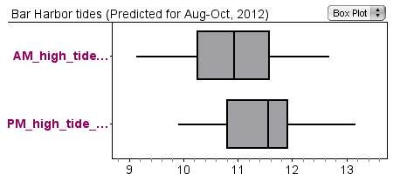

1. Are the heights of the a.m. and p.m. high tides the same or different?

How do the **total ranges** for each group of tides compare?

How do the **inter-quartile** ranges (the length of the boxes) compare?

How do the **medians** compare?

2. Describe how the two graphs are positioned relative to each other.

Words you might use include:

shifted

overlap

median

inter-quartile range (or box)

width

whiskers

length

longer/shorter than

greater/less than

extreme values

3. How would you answer the question?