How do the number of chromosomes compare between plant and animal species?
Data Literacy Project
Background
The number of chromosomes in the cells of organisms is different between species. For example, Adder’s-tongue ferns (Ophioglossum reticulatum) – named for their snake-like spore-producing stalk – have 1,440 chromosomes (720 pairs) and humans (Homo sapiens) have 46 (23 pairs)!
Question: Do plants tend to have more chromosomes than animals do?
The table displays chromosome numbers for various plants and animals. This is not a comprehensive list and should be considered a representative sample for each group.
(Data source: https://en.wikipedia.org/wiki/List_of_organisms_by_chromosome_count)

ANIMAL SPECIES | Diploid number of chromosomes |  | PLANT SPECIES | Diploid number of chromosomes
Carp | 104 |  | Field Horsetail | 216
Turkey | 80 |  | Rattlesnake fern | 184
Coyote | 78 |  | Grape ferns | 90
Chicken | 78 |  | Cotton | 52
White-tailed deer | 70 |  | Pineapple | 50
Horse | 64 |  | Potato | 48
Elephant | 56 |  | Tobacco | 48
Striped skunk | 50 |  | Wheat | 42
Human | 46 |  | Mango | 40
Dolphin | 44 |  | Rice | 24
Rabbit | 44 |  | Husk Tomato | 24
Rhesus Monkey | 42 |  | Rice | 24
Lion | 38 |  | Maize | 20
Earthworm | 36 |  | Cabbage | 18
Zebrafish | 26 |  | Pea | 14

Make a dot plot that shows the frequency of chromosome number for the two groups of organisms (plants and animals).

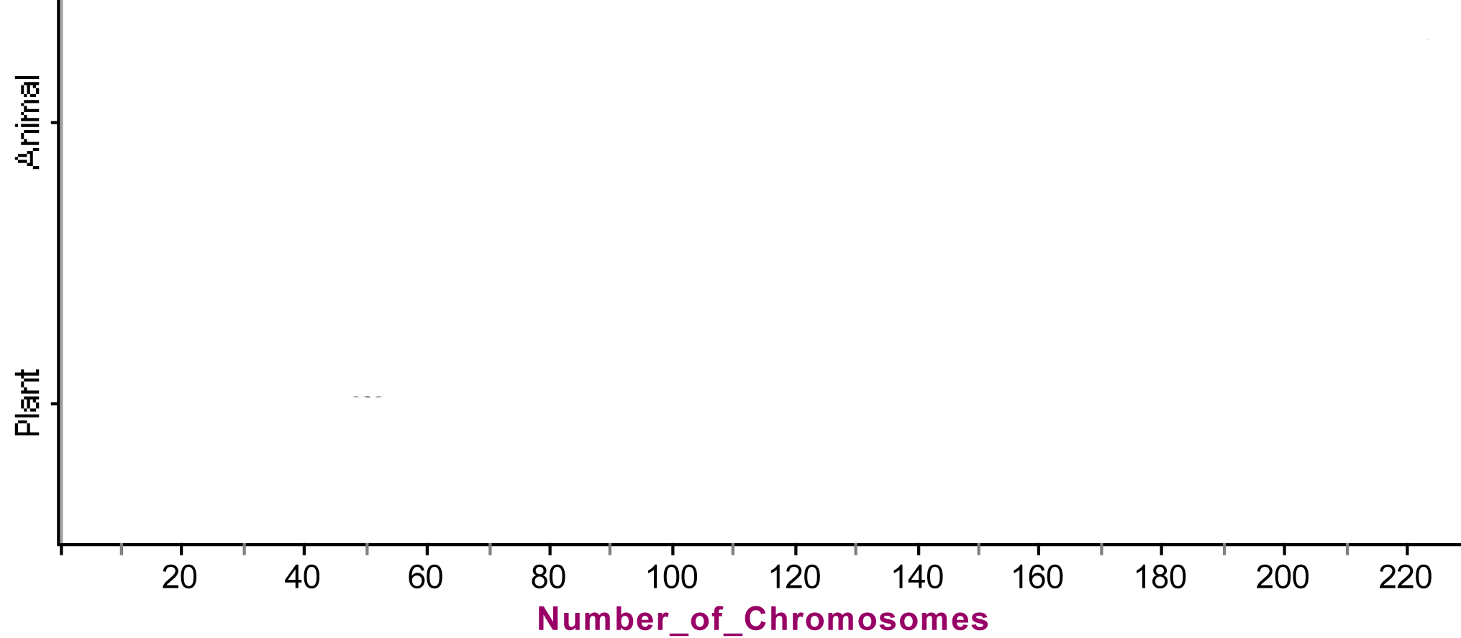

Frequency

2. a. Based on your plot, how would you describe the variability of chromosome number for this group of plant species?

b. How would you describe the variability of chromosome number for this group of animal species?

3. What statement can you make about the difference between chromosome numbers of plants and animals in general?

