## How many major earthquakes occur worldwide each year?

Data Literacy Project

**Background**: As you might expect, each year a different number of major earthquakes occurs around the globe. We’ll call an earthquake major if it is 7.0 or greater on the Richter scale. (For comparison, the quake that occurred in southern Maine in October 2012 was 4.3). A dot plot is a great way to see at a glance how many major earthquakes typically occur around the world each year.

**Question: *How many major earthquakes (≥ 7.0) occur around the world in a year?***

The sample below includes earthquakes from 1900 to 1999.

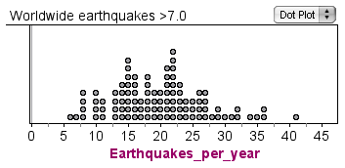

Frequency

Source: US Geological Survey, http://earthquake.usgs.gov

1. What does each dot in the graph represent?
2. How would you describe the variability in the number of major earthquakes that occur around the world each year?
3. **Extended thinking**: In 2011 there were a total of 20 earthquakes worldwide that were magnitude 7.0 or greater. How many major earthquakes *do you think are likely to occur in* 2012?